Regular Verbs

🔹 What is Regular Verbs
# Source: AI Source: Provided by: [Data Path: Persons Table -> ID Column: 1, Name_En Column: Motasem Essam] -> From: [Chatgpt (GPT-4-turbo)] on [7/27/2025]
A regular verb is a verb that forms its past tense and past participle by simply adding -ed or -d to the base form.

✅ Definition:
# Source: AI Source: Provided by: [Data Path: Persons Table -> ID Column: 1, Name_En Column: Motasem Essam] -> From: [Chatgpt (GPT-4-turbo)] on [7/27/2025]
A regular verb is a verb that follows a consistent pattern when changing into the past tense and past participle — usually by adding -ed.

🧩 Form:
# Source: AI Source: Provided by: [Data Path: Persons Table -> ID Column: 1, Name_En Column: Motasem Essam] -> From: [Chatgpt (GPT-4-turbo)] on [7/27/2025]
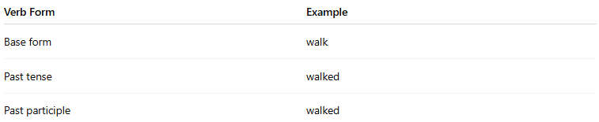
Verb Form | Example
Base form | walk
Past tense | walked
Past participle | walked
🟩 All regular verbs have the same past tense and past participle form.

📚 Examples of Regular Verbs:
# Source: AI Source: Provided by: [Data Path: Persons Table -> ID Column: 1, Name_En Column: Motasem Essam] -> From: [Chatgpt (GPT-4-turbo)] on [7/27/2025]
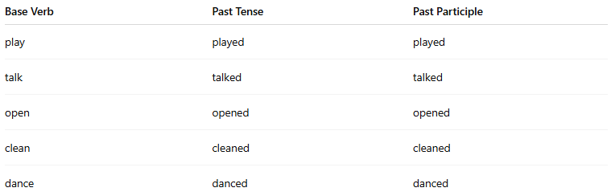
Base Verb | Past Tense | Past Participle
play | played | played
talk | talked | talked
open | opened | opened
clean | cleaned | cleaned
dance | danced | danced

✍️ Spelling Rules for Regular Verbs:
# Source: AI Source: Provided by: [Data Path: Persons Table -> ID Column: 1, Name_En Column: Motasem Essam] -> From: [Chatgpt (GPT-4-turbo)] on [7/27/2025]
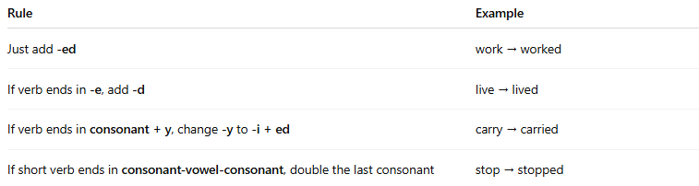
Rule | Example
Just add -ed | work → worked
If verb ends in -e, add -d | live → lived
If verb ends in consonant + y, change -y to -i + ed | carry → carried
If short verb ends in consonant-vowel-consonant, double the last consonant | stop → stopped

🔁 Regular vs Irregular Verbs:
# Source: AI Source: Provided by: [Data Path: Persons Table -> ID Column: 1, Name_En Column: Motasem Essam] -> From: [Chatgpt (GPT-4-turbo)] on [7/27/2025]
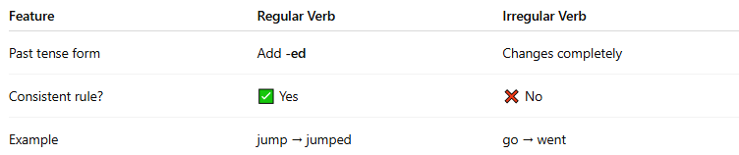
Feature | Regular Verb | Irregular Verb
Past tense form | Add -ed | Changes completely
Consistent rule? | ✅ Yes | ❌ No
Example | jump → jumped | go → went

✅ Summary Table:
# Source: AI Source: Provided by: [Data Path: Persons Table -> ID Column: 1, Name_En Column: Motasem Essam] -> From: [Chatgpt (GPT-4-turbo)] on [7/27/2025]
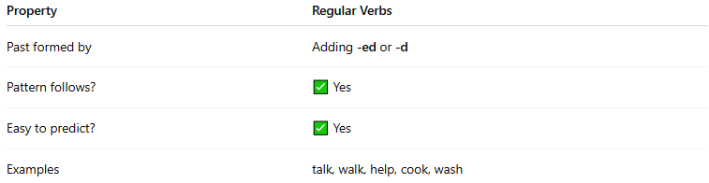
Property | Regular Verbs
Past formed by | Adding -ed or -d
Pattern follows? | ✅ Yes
Easy to predict? | ✅ Yes
Examples | talk, walk, help, cook, wash

